Ongoing Group (Group 5 or “No Structure Group”) ECITE 2013

The forming of the Ongoing Groups, I have experienced as stressful, frustrating and not quite working. For several years (I think since Austria, 2006) nearly every year the same game is made (taken from adult education) ​​to form these groups: To write down on a sheet of paper a word, which is important to oneself as a subject for the group work. Then the papers are distributed well visible on the floor, and everybody can walk around and watch all the expressions, also shifting the positions of them to form clusters. At some time, everybody has to line up in front a cluster that attracts most, in terms of the topics. Of course, and this is not mentioned loudly, by looking around, who else is in too.

Mostly, accumulations are built by people who gravitate towards one another in some degree, like in a sociogram. So you can also leave, if you prefer not being with certain people in this "intimate group". What is more important, the topics or the people, is not clearly to say. Not rarely, some large accumulation of people results around a cluster of papers, while others stay empty or with only one or two courageous people. What doing with the rest, where there is too less people? Join another group! - It’s not completely satisfying. Sometimes it results also a "residual group" with people who did not find a place or see themselves not in such coalitions or fit not into the structure or dynamic.

The best experiences with Ongoing Groups in ECITE I made with those that have been arranged more or less at random, means f. ex. to number consecutively from 1 to 5, and all 1 and all 2, etc. are together. There have also been organisers who have balanced the groups a little with respect to experience, age and country in advance. The principle behind it is that we are more or less professionals and can work and dance with everybody, project-related and for a while. Intermixing is fine and a fruitful challenge. To look mainly about relationship in professional settings can be boring and limiting.

Last year, I was just joining a group, as it was already formed, and I was following their subjects. We had fun, inspiration and a good time. Everybody was contributing some idea or structure, and the rest of the time we were warming up, dancing together and sharing.

This year, the organisers asked for 4-5 Ongoing Groups. But there were only 2 big and an unstable one. Rather to join a large group, I found myself again in the residual group which has needed a very long time then for the initiation phase, finding connections and secure the existence. Already during the transfer, walking into the assigned space, from 12 “members” only 4 were arriving (8 were jumping off!). Then, embarrassed and emotional stressful efforts followed, to join and deal with people who dropped away or left over. For several days being in this atmosphere without sureness and commitment, if and who is staying. This uncertainty was reinforced by several well-meaning daily calls of the organisers, to change the group, if it is not working…
But finally we stayed, struggled together, have found each other after a few minor conflicts and steps and we were taking off and even flying. At times like a journey. It was energizing, authentic and also touching. Somehow it was about sharing the territory or co-creating a microcosm. Every day I counted with some leaving members, instead people came along and the group increased.

The group, the dynamic of the uncertain membership, identity and unclear definition as well as the extremely open structure have provoked or released emotions in several members. But they have also given the opportunity and the freedom to act out personal things and making new experiences.

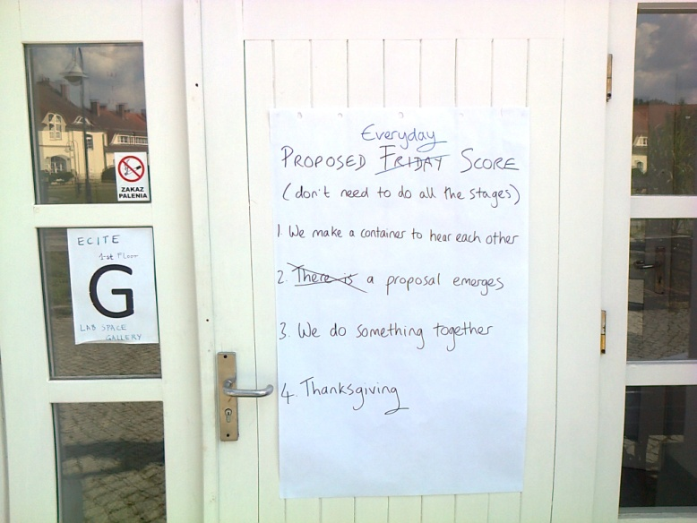

PROPOSED FRYDAY / EVERYDAY SCORE
(don’t need to do all the stages)
1. We make a container to hear each other
2. There is a proposal emerges
3. We do something together
4. Thanksgiving
(Proposed by Jenny)

The Ongoing Group for me was finally a rich human experience, and I got to know new people. However, in terms of teaching and exchange, I professionally could not take much. But rather a lively, sometimes chaotic dynamic group than a boring, professional study group.

Ongoing Group members: Michel (UK), Lion (Can), Dorothee (CH), Saskia (UK), Maren (CH), Jenny (UK), Nina (Ukr), Lior (Israel), Ulli (D), Paulina (Pol), Julian (Arg), Klaus (DK), Walter (CH), and others

Walter Weiler Sept. 2013

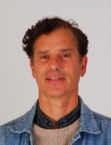
Walter Weiler
Hürst-Str. 81
CH- 8046 Zürich
Switzerland
0041 44 361 57 53
walterweiler@bluewin.ch

